

HR Module
& Manual Ordering

Introduction to the HR Module
Upon initial login, the Home Page displays several different folders for quick access to applicants based on the status of their background report. There is also a search feature at the top of the page which can be used to search for applicant reports.
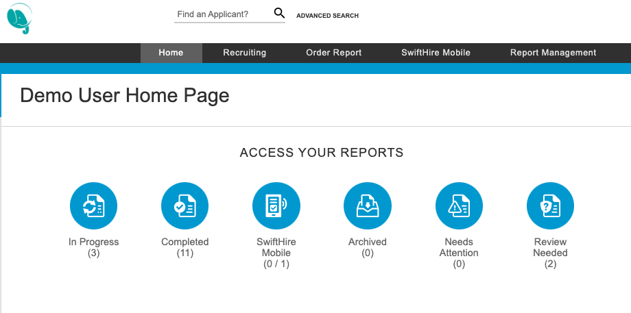
- In Progress: The applicant still has one or more searches that have not been completed. This way, you can keep track of an applicant in real time, even if there are a few searches still pending.
- Completed: The applicant's background check is completely finished. You can leave an applicant in this status as long as you like; eventually, you should move completed applicants to the Archived category as explained later.
- SwiftHire: Includes pending links awaiting completion by the applicant or pending review by the user, meaning there is not yet a report in the system for that order.
- Archived: Used for organizational purposes. Completed applicants can be moved to the Archived category once you no longer need to actively monitor their background.
- Needs Attention: This category conveniently shows only applicants that have either 1) an unread status update, or 2) missing information that you need to supply.
- Review Needed: This category shows you all candidates that have a criminal record, unverified school or employment record, or positive drug test.

Search Feature
The Find an Applicant feature at the top of the Home Page can be used to search for applicants with a report in the system, but search results will not include applicants in the SwiftHire folder.

Order Report

Enter Applicant Information
At the top of the page, click on the Order Report tab and enter the applicant’s basic information including name, date of birth, social security number, and address in the fields as shown below.
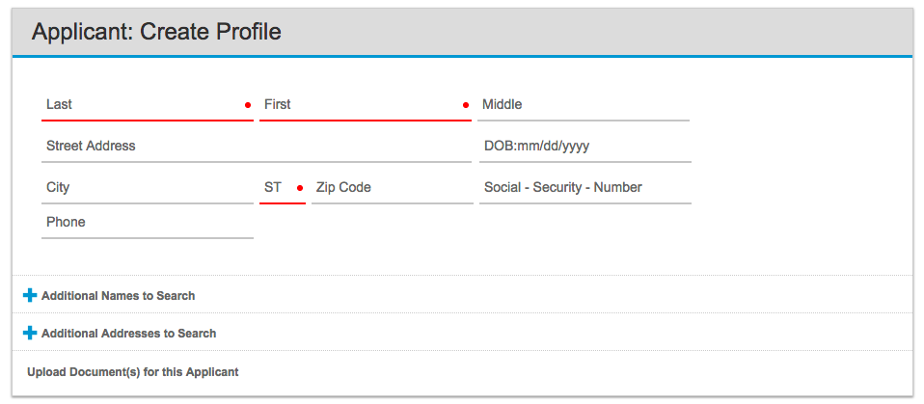

Make sure to include all information you have on file. If you leave out a required field - for example, if you leave out the date of birth when ordering a county criminal - the system will alert you to missing data.

Depending on your account setup, you may have one or more of the optional fields available as shown below:
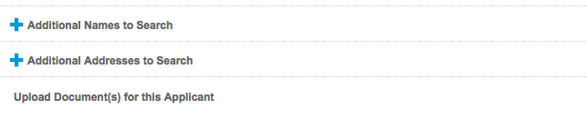

- Additional Names to Search: Click this link to add one or more names as an AKA (alias/maiden names). This will allow you to order searches for multiple names simultaneously. You can add extra names by clicking + Add another, or remove a name you've already added by clicking the Remove button on the right.
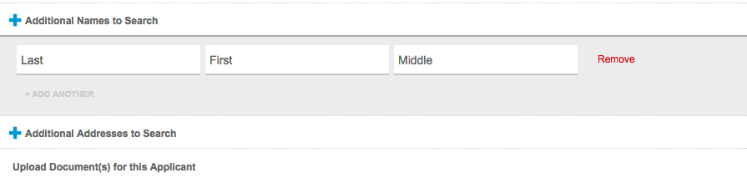

- Additional Addresses to Search: Click this link to add one or more sets of City, State, and Zip to the order. You can add extra addresses by clicking + Add another, or remove an address you've already added by clicking the Remove button on the right.
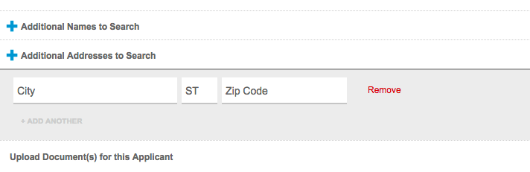

- Upload Document(s) for this Applicant: Click this link to upload a release form or other document that will accompany this background screening order. By uploading necessary documents at this stage, rather than faxing or emailing them, you can cut down on the turnaround time for the background screen.
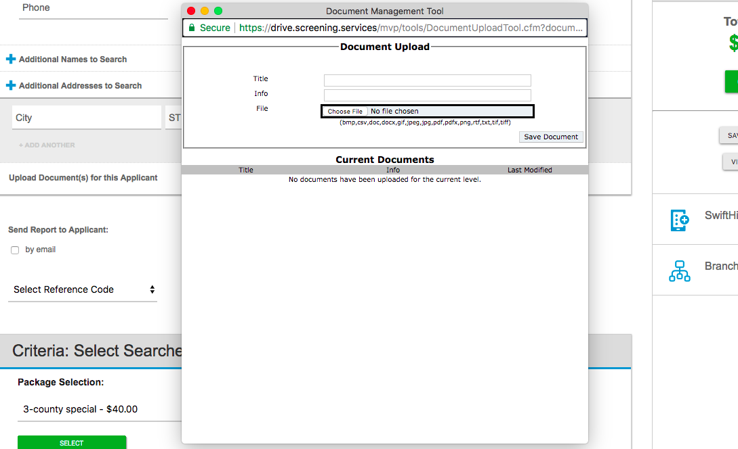

- Send Report to Applicant: If this option is visible, then you can ensure that a final copy of the report is sent automatically to the applicant, in addition to being made available to you. Check by email or by fax, or both, to choose the delivery method, and the system will prompt you to enter the email and/or fax number as shown below:
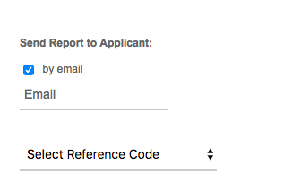

- Reference Code: Depending on your account settings, this may be a required or optional field. A reference code, billing code, department code, etc can be entered into this field to be stored with the report, as well as displayed on the detailed invoice.

Choose the Package or Searches
Depending on your account setup, you may be able to order custom prebuilt packages, individual searches, or both. Click the dropdown under Package Selection as shown below. From there, you can choose from the package, bundle, or individual searches and press Select to continue with the order.

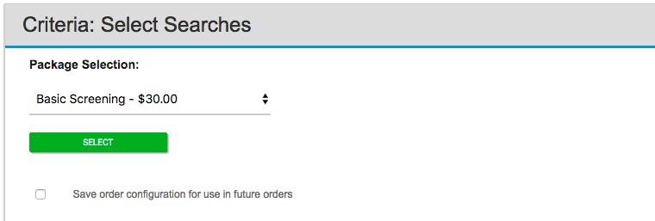

If a package or bundle is selected, the searches available in that package/bundle will automatically appear. If you choose to order individual searches, then you can click on each search needed for the order as explained later under ‘Adding and Removing Search Types.’

Any searches that require additional information will be in red text indicating missing data, while any searches that are ready to be ordered will have a green check mark. All search types in the order must have a green check mark before the order can be placed successfully:
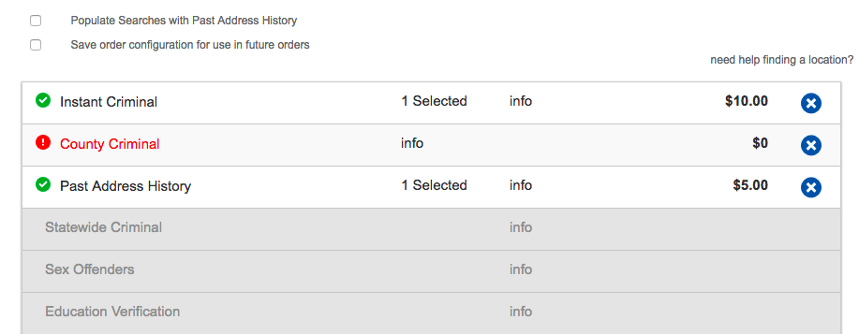

Auto-Populate or Choose for Location-Based Searches
Depending on your account setup, the system may automatically fill in the jurisdictions for location-based searches according to the applicant’s current residence and/or address history. It is best practice to review the jurisdictions that auto-populate to ensure those match any locations provided by the applicant on their application.

If your search jurisdictions do not auto-populate, click on the search to fill in the necessary fields. Remember to click Save Selection when finished, and the red icon should change to a green check mark.

Adding More Entries Per Search Type
Additional schools, employers, counties, etc, can be added by clicking the + Add Another link at the bottom of any search type:

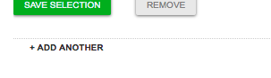

Adding and Removing Search Types
If enabled on your account, you may be able to add or remove search types during the ordering process.

To remove a search type, click the X to the far right of the search name. If you remove it accidentally, just re-click the title to add it again; all your previously saved information will be remembered.

To add a new search type to your order, click the Show More Searches bar to show the available a la carte options. From there, or if you are ordering individual searches, click the grayed-out search name to add it to the order and input any required information.
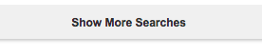

Branch Ordering
Please Note: The following information only applies if your account has multiple branches (also known as locations or child accounts), and the "Order for Branches" user permission is enabled for your individual account.

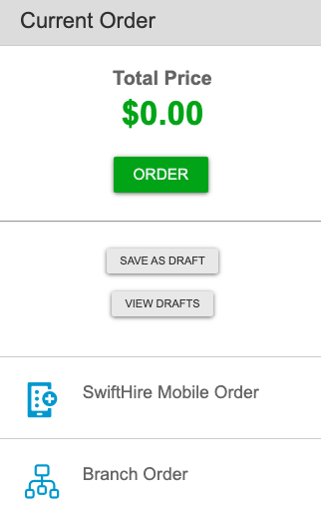
To place an order on behalf of one of your branch accounts, navigate to the Order Report tab and select Branch Order on the right side, as shown below:

A pop-up will display for you to select the branch account and the user under whom to place the order. The results of the background check will be delivered to the chosen user, according to that user's settings. Once the branch and user are selected, the page will refresh and display the branch name within the Package Selection box.
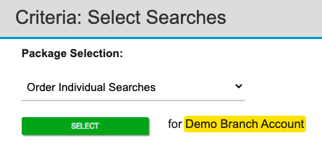
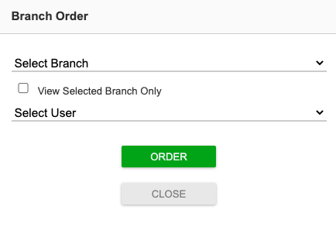

Confirm and Submit Your Order
Once all necessary information has been entered and reviewed for accuracy, scroll to the top of the page, click the green Order button on the right-hand side to place the order. If any fields are missing data, you will be prompted to make corrections before you can submit.
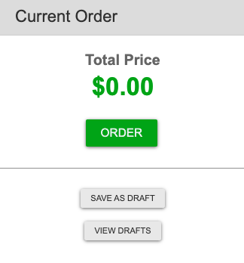

Not ready to place the order just yet? Choose ‘Save as Draft’ instead, and you can return here later to finish placing the order. To return to a draft order, navigate to the Order Report page and click View Drafts on the right-hand side.

