

SwiftHire Mobile
HR Guide

Introduction to SwiftHire
SwiftHire allows users to send self-screening invitations directly to applicants. The applicant who receives the invitation can click a personalized link, electronically sign an electronic consent document (if enabled by your background check provider), and fill out their information to initiate the background check. This guide will help outline the process for SwiftHire setup and ordering.

SwiftHire Settings
Before a background check can be ordered via SwiftHire, the individual user settings must be configured; these settings can be accessed at any time from the SwiftHire dashboard as shown below, even after they have been initially configured.
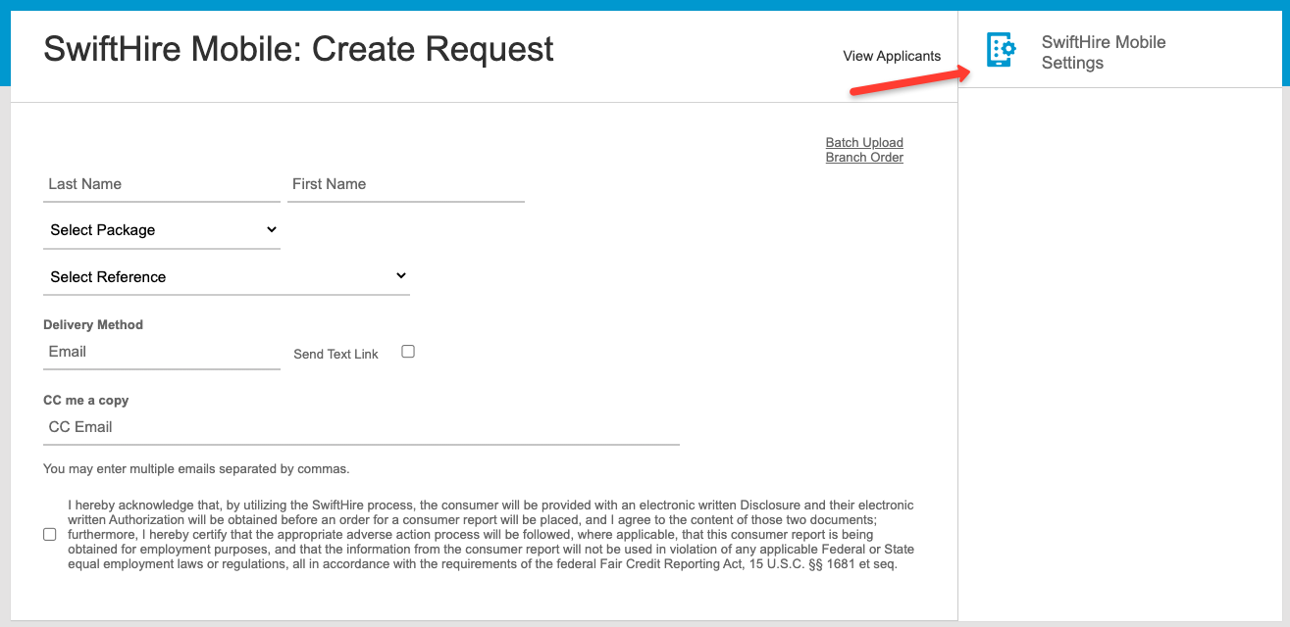

Request Email:
This section is where the invitation email verbiage and settings are configured. It includes the following fields:
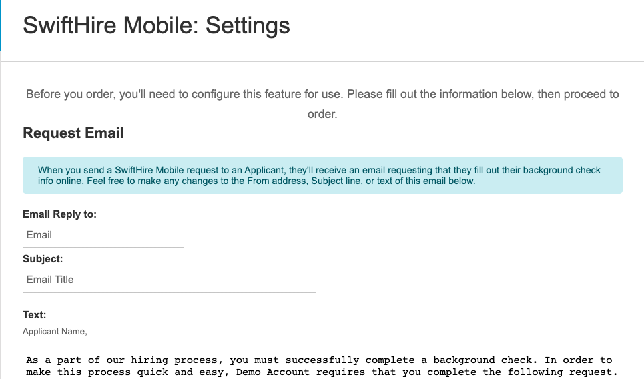

Email Reply to: The email address of the person or organization requesting the background check. The applicant can reply to the SwiftHire invitation if necessary, and the reply will go to this email address.
Subject: This is the subject line of the email invitation. A specific Subject line can be helpful to applicants when searching their inbox (for example, ABC Company Background Request).
Text: This is the actual content of the email. Default verbiage is included but can be easily customized to include any additional instructions and guidance for your applicants. The system will automatically add the SwiftHire link at the bottom of the email when sent (the link says “Get Started”).


Reminder Email(s):
Here you can construct the main reminder email along with any number of optional reminder emails, which can all be sent to your applicants automatically. Each reminder has three fields:
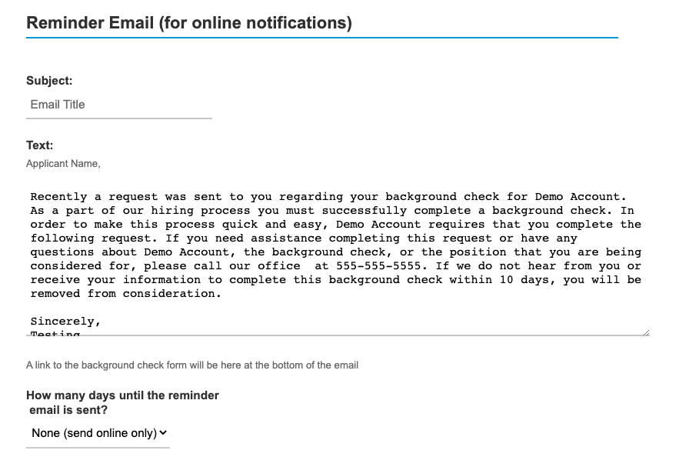

Subject: The subject line of the reminder email. For example: “Reminder - Complete Background Screening Request for ABC Company”
Text: This is the actual content of the reminder email. Default verbiage is included but can be easily customized to include any additional instructions and guidance for your applicants. The system will automatically add the SwiftHire link at the bottom of the email when sent, just like the initial Request Email.
How many days until the reminder is sent?: The system tracks how many days it has been since the original invitation was sent and can automatically send the reminder after the number of days indicated here have passed. For example: If the reminder is set to send after 2 days, the applicant receives the invitation on a Monday and has not completed it, they will automatically receive the reminder on Wednesday.. To add additional reminders, click “+ Add an automatic email” at the bottom of this screen. Multiple reminders can be used, each with a different number of days, to create escalating verbiage for applicants who have not submitted their information.

Notifications:
If desired, one or more users on the account can receive a notification email each time a SwiftHire link is completed by an applicant.

Process:
When an applicant completes their SwiftHire invitation, there are three options for how the order will begin processing:
WITH Review: You can choose to review the information and make changes before initiating the order for processing. If you choose WITH a review, then the list of SwiftHire orders pending review can be accessed via the Home Page, either under the SwiftHire or Report Management tab.
WITHOUT Review: Orders will begin processing immediately once the applicant submits their information.
Applicant Pay via Credit Card: The applicant will be prompted to pay for their background check via credit card (if configured by your background check provider). The background check will be ordered, and the applicant will be sent an invoice as receipt for the order.

Once all sections are filled out, click UPDATE to save the settings. You are now ready to place a SwiftHire order!

How to Order
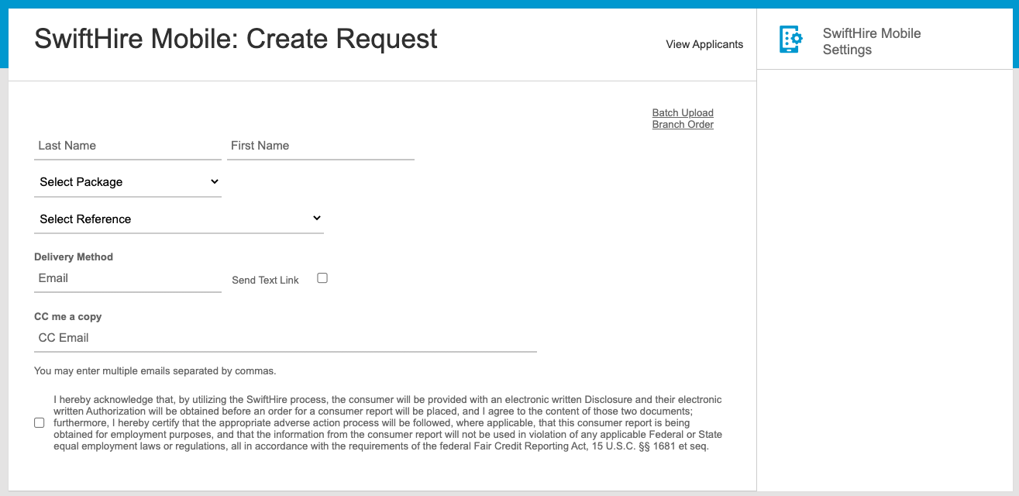
Ordering background checks using SwiftHire Mobile can be done in a few easy steps. After you (or your background check provider) have configured your SwiftHire settings:
1. Click the SwiftHire Mobile tab to navigate to the Create Request page.
2. Enter the applicant’s Last Name, First Name, select the package and reference code (if applicable).
3. Choose a delivery method. The email address is required, but you can also send the link via text message! Of note, if you choose to send the link via email and text, the applicant will receive both invitations; once one is fulfilled, the other becomes invalid.
4. Check the acknowledgement box, and click Submit. You will see a success message like the one pictured below!
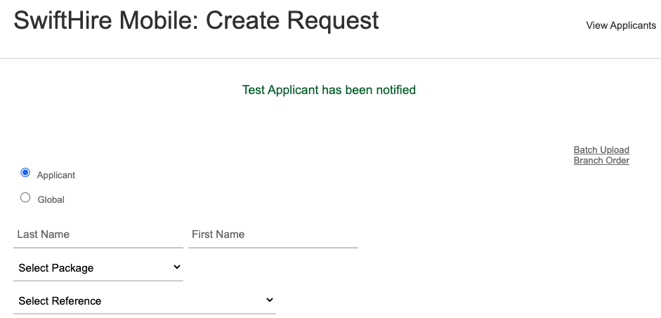

Managing SwiftHire Applicants
Depending on your reminder and notification settings, you may wish to monitor and manage your applicants from your account. You can access these applicants by either going to the SwiftHire tab and then View Applicants, or under the Report Management tab and choosing the SwiftHire folder on the right-hand side. Any applicants listed in this folder either a.) have not yet submitted their information, or b.) are pending review by a user on the account.
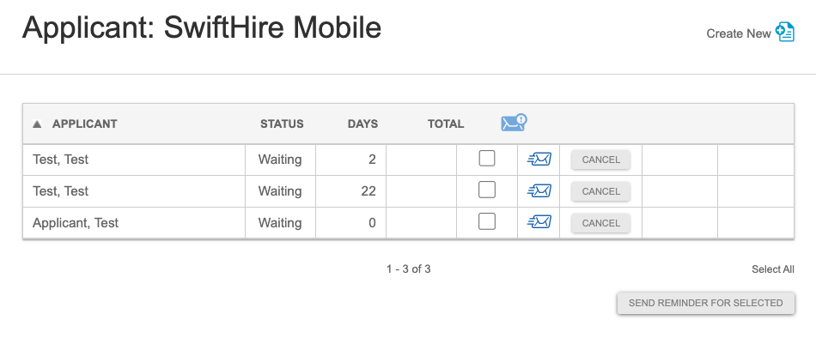
From this page, you can:
- Manually send the reminder to one or more applicants by checking the box and selecting Send Reminder for Selected.
- Edit the applicant’s email address associated with the link prior to sending the Reminder. To do this, either click on the envelope to the right of their name or check the box for a single applicant and click Send Reminder for Selected:
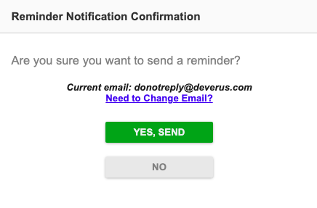
- Cancel any pending links, which will render any links previously received by the applicant as invalid.
You are now set to use SwiftHire to request and manage your background checks!

